JRAHS 2006 TRIAL HSC - EXT I

Question 1. Marks

(a) Solve for x: 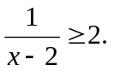 3

(b) Find: 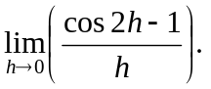 2

- The point P divides 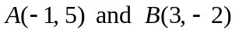 in the ratio 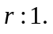
(i) Find the coordinates of P in terms of r. 2

  - Find the value of r when the line 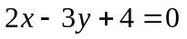 intersects 2
the interval AB.

(d) Evaluate 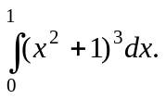 3

Question 2. [START A NEW PAGE]

- A plate is initially heated to 55⁰ C, and it then cools to 41⁰ C in 10 minutes.
If the surrounding temperature, S⁰ C, is 22⁰ C and assuming Newton’s Law of Cooling:
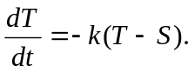
  - Find the temperature of the plate 25 minutes from the 3
start of cooling (to 1 decimal place).

(ii) Find the time for the plate to cool to 25⁰ C (to 1 decimal place). 2

(iii) Sketch the graph of the rate of temperature, 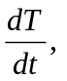versus the temperature T. 1

- The displacement x metres of a particle after t seconds, is given by:
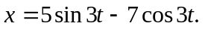

(i) Show that the motion of the particle is SHM. 2

(ii) Find the maximum displacement. 1

  - Find the time when the particle first passes through the centre of 2
motion (correct to 1 decimal place).

(iv) Sketch the graph of the acceleration versus displacement x. 1
Question 3. [START A NEW PAGE] Marks

(a) Differentiate 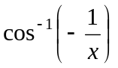 with respect to x. Answer in simplified form. 3

(b) (i) On the same set of axes, sketch the graphs of 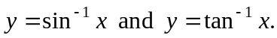 2

- Given that: 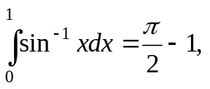 find the area of the region bounded by 3
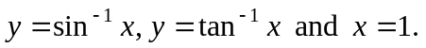

(c) (i) Show that 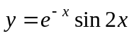 is a solution to the differential equation: 3
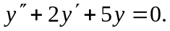

(ii) Hence, or otherwise, find 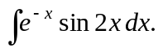 1

Question 4. [START A NEW PAGE]

- A fire truck arrives at a burning building 10 metres high and 15 metres wide.
The water nozzle hose on the fire truck is 2 metres above the ground and d metres
from the building, as shown in the diagram.

y

A

B

O

10 m

15 m

2 m
d m

x

The angle of elevation of the hose, α, can be adjusted to range from 10⁰ to 45⁰.
The parametric equations for the water particles from the nozzle are given by:
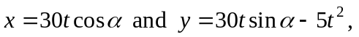 where t is the time in seconds when g = 10.

- Show that the trajectory path of the water is given by the equation: 1
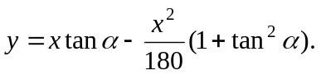
(ii) The hose nozzle is adjusted to an angle of elevation of 45⁰. 2
Find the distance, d, from the building if the water is to reach the furthest
point B on top of the building as shown (answer to the nearest centimetre).
Q 4 continues over the page
Q 4 part (a) continued Marks
(iii) Find the angle of elevation α of the nozzle, for the water to 2
reach position A, when the hose nozzle is 20 metres from the
burning building (answer to nearest minute).

(b) Find 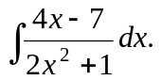 3

- (i) For 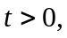 find the limiting sum of: 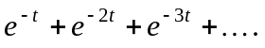 1
(ii) Hence, find an expression for the series; 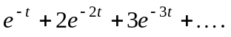 1

(d) A semi-circle of radius r has the equation: 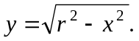
(i) Find 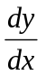 at the point 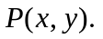 1

- Prove that the tangent, at any point P on the semi-circle, is 1
perpendicular to the radius.

Question 5. [START A NEW PAGE]

- Find the greatest coefficient in the expansion of 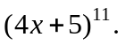 3
(Leave the answer in index form).

- A ping pong ball is initially placed 1 metre beneath the surface of the water,
as shown in the diagram.
x

O water surface
1 m

The ping pong ball is released in the water with an acceleration of m/s²,
where 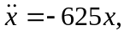 and where x metres is the displacement of the motion
measured from the water surface.

(i) Is the motion of the ping pong ball only SHM? Give reasons. 1
(ii) Prove that: 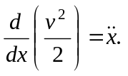 2
- Find the expression for the ping pong ball's velocity v m/s 2
when it is in the water.
(iv) Find the velocity of the ball at the water's surface. 1
(v) Assuming there is no air resistance and the acceleration due to gravity 2
is 10 m/s², derive an expression for the displacement in air in terms of v
(vi) Find the maximum height that the ping pong ball reaches above the 1
surface of the water.
Question 6. [START A NEW PAGE] Marks

- How many groups of 2 men and 2 women can be hosen from 6 men 2
and 8 women?

(b) Six letter words are formed from the letters of the word CYCLIC.
(i) How many different 6-letter words can be formed? 2
(ii) How many 6 letter words can be formed, if no ‘C’s are together? 2
- What is the probability of all the ‘C’s together, if it is known a vowel is 2
at the end?

(c) Prove, by the method of mathematical induction that: 4

Question 7. [START A NEW PAGE]

- At the end of each month, for 15 years, a man invests $400 at an interest rate
Which is paid monthly at 6% pa.
- Show that the value of his first payment, at the end of 15 years, 2
is $976.75

(ii) Find the value of the man’s total investment at the end of the 15 years. 2

- A circle, centre O with a constant radius r, is such that the chords AC and BD
intersect at point E, 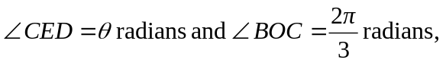
as shown the diagram.

A

D

θ
Not to scale

C

E

B

O

(i) Show that the sum of the arcs AB and CD equal 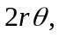 give reasons. 3

- Show that the perimeter P of the shape ABCD, where BC, AD are chords 2
and CD, AB are arc lengths, is given by:
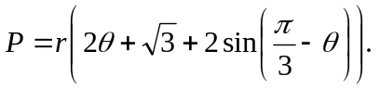
- Find the value of θ, in the domain 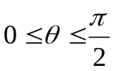 for the perimeter of ABCD 3
to have a maximum value. Justify your answer.

